Aim: To obtain the classification of various classes using the k-Nearest Neighbor approach
IDE: Google Collab

Theory:
This algorithm is used to solve the classification model problems. The K-nearest neighbor or K-NN algorithm basically creates an imaginary boundary to classify the data. When new data points come in, the algorithm will try to predict them to the nearest boundary line. Therefore, a larger k value means smoother curves of separation, resulting in less complex models. Whereas a smaller k value tends to overfit the data, resulting in complex models. It’s very important to have the right k-value when analyzing the dataset to avoid over-fitting and under-fitting of the dataset.

The model representation for KNN is the entire training dataset. It is as simple as that. KNN has no model other than storing the entire dataset, so there is no learning required. Efficient implementations can store the data using complex data structures like k-d trees to make look-up and matching of new patterns during prediction efficient. Because the entire training dataset is stored, you may want to think carefully about the consistency of your training data. It might be a good idea to curate it, update it often as new data becomes available, and remove erroneous and outlier data.

The K-NN algorithm assumes the similarity between the new case/data and available cases and puts the new case into the category that is most similar to the available categories. The K-NN algorithm stores all the available data and classifies a new data point based on similarity. This means that when new data appears, it can be easily classified into a well-suited category by using K- NN algorithm. The K-NN algorithm can be used for Regression as well as for Classification but it is mostly used for the Classification problems.

K-NN is a non-parametric algorithm, which means it does not make any assumption on underlying data. It is also called a lazy learner algorithm because it does not learn from the training set immediately; instead, it stores the dataset, and at the time of classification, it acts on the dataset. The KNN algorithm at the training phase just stores the dataset, and when it gets new data, it classifies that data into a category that is very similar to the new data.

Example: Suppose we have an image of a creature that looks similar to a cat and a dog, but we want to know whether it is a cat or a dog. So, for this identification, we can use the KNN algorithm, as it works on a similarity measure. Our KNN model will find the similar features of the new data set to the cats and dogs images, and based on the most similar features, it will put it in either the cat or dog category.

Methodology:
- Load the basic libraries and packages
- Load the dataset
- Analyze the dataset
- Pre-process the data

- Visualize the Data
- Separate the feature and prediction value columns
- Select the number K of the neighbors
- Calculate the Euclidean distance of K neighbors
- Take the K nearest neighbors as per the calculated Euclidean distance.
- Among these k neighbors, count the number of data points in each category.
- Assign the new data points to that category for which the number of neighbors is maximum.
- Our model is ready.

Pre Lab Exercise:
- What is K in the KNN approach?
The value of K in the KNN algorithm is a hyperparameter that determines the number of neighbors to consider when making a prediction. The choice of K is crucial, as it affects the algorithm’s sensitivity to noise and the stability of the predictions. A smaller value of K can lead to overfitting, while a larger value can result in underfitting.
- Which are the types of distance metrics?
The types of distance metrics are:
- Euclidean distance- measures the shortest distance between two points in a Euclidean space, often used in clustering and classification tasks.
$$d=\sqrt{{(x_{1}-y_{1})}^{2}+{(x_{2}-y_{2})}^{2}}$$
- Manhattan distance- calculates the distance between two points by summing the absolute differences in their coordinates.
$$d=\left|x_{1}-y_{1}\right|+|x_{2}-y_{2}|$$
- Minkowski distance- generalizes the Euclidean and Manhattan distances.
$$d={(\sum{|}x_{i}-y_{i}|)}^{1/p}$$
- Hamming distance- measures the difference between two strings of equal length.
- Cosine similarity- measures the similarity between two vectors based on the cosine of their angle.
- What can be the criteria for selecting the value of K?
- Bias-variance trade-off: small K implies low bias, high variance, making the model sensitive and may overfit; large K implies high bias, and low variance, and the model becomes smoother but may overfit.
- Dataset size: larger datasets can handle larger K values without losing local detail; for small datasets, a smaller K is often better to capture local patterns.
- Cross-validation: trying different values of K and choose the one with the highest accuracy.
- Odd number for classification: for binary classification, choose odd K to avoid ties in voting.
- Square root of dataset size: a common rule is $K=\sqrt{N}$, where N is the number of samples.
- What are the advantages of the KNN algorithm?
- The KNN algorithm is simple and easy to understand, that is no complex training required;
- No training phase, just store data and predict;
- Works well for small datasets, high accuracy in simple problems;
- KNN algorithm is flexible.
- No assumptions about data.

Program (Code):

import time
import numpy as np
import pandas as pd
import matplotlib.pyplot as plt
import seaborn as sns

from sklearn.datasets import load_digits
from sklearn.model_selection import train_test_split, GridSearchCV
from sklearn.preprocessing import StandardScaler
from sklearn.pipeline import Pipeline

from sklearn.neighbors import KNeighborsClassifier
from sklearn.ensemble import RandomForestClassifier
from sklearn.neural_network import MLPClassifier

from sklearn.metrics import (
accuracy_score,
precision_score,
recall_score,
f1_score,
confusion_matrix
)

digits = load_digits()
X = digits.data
y = digits.target
images = digits.images

plt.figure(figsize=(8, 4))
for i in range(10):
plt.subplot(2, 5, i + 1)
plt.imshow(images[i], cmap="gray")
plt.title(f"{y[i]}")
plt.axis("off")
plt.suptitle("Sample Digits")
plt.tight_layout()
plt.show()

X_train, X_test, y_train, y_test = train_test_split(
X, y, test_size=0.2, random_state=42)

knn_pipeline = Pipeline([
("scaler", StandardScaler()),
("knn", KNeighborsClassifier())
])

knn_param_grid = {
"knn__n_neighbors": [3, 5, 7, 9, 13, 15, 20]}

rf_pipeline = Pipeline([
("rf", RandomForestClassifier(random_state=42))
])

rf_param_grid = {
"rf__n_estimators": [25, 50, 100, 200, 500],
"rf__max_depth": [None, 10, 20]}

mlp_pipeline = Pipeline([
("scaler", StandardScaler()),
("mlp", MLPClassifier(
max_iter=1000,
random_state=42,
early_stopping=True
))
])

mlp_param_grid = {
"mlp__hidden_layer_sizes": [(64,), (128,), (64, 64)],
"mlp__activation": ["relu", "tanh"],
#"mlp__alpha": [0.0001, 0.001],
"mlp__learning_rate_init": [0.001, 0.01, 1.0, 5.0, 10.0]
}

#Training the model
def train_with_timing(pipeline, param_grid):
start = time.time()
grid = GridSearchCV(
pipeline,
param_grid,
cv=5,
scoring="f1_weighted",
n_jobs=-1
)
grid.fit(X_train, y_train)
train_time = time.time() - start
return grid, train_time

knn_grid, knn_train_time = train_with_timing(knn_pipeline, knn_param_grid)
rf_grid, rf_train_time = train_with_timing(rf_pipeline, rf_param_grid)
mlp_grid, mlp_train_time = train_with_timing(mlp_pipeline, mlp_param_grid)

#Inferencing the model
def inference_time(model):
start = time.time()
model.predict(X_test)
return time.time() - start

knn_test_time = inference_time(knn_grid.best_estimator_)
rf_test_time = inference_time(rf_grid.best_estimator_)
mlp_test_time = inference_time(mlp_grid.best_estimator_)

#Evaluation
def evaluate_model(model):
y_pred = model.predict(X_test)
return {
"Accuracy": accuracy_score(y_test, y_pred),
"Precision": precision_score(y_test, y_pred, average="weighted"),
"Recall": recall_score(y_test, y_pred, average="weighted"),
"F1-score": f1_score(y_test, y_pred, average="weighted")
}

knn_metrics = evaluate_model(knn_grid.best_estimator_)
rf_metrics = evaluate_model(rf_grid.best_estimator_)
mlp_metrics = evaluate_model(mlp_grid.best_estimator_)

#Result with comparison
results_df = pd.DataFrame(
[knn_metrics, rf_metrics, mlp_metrics],
index=["KNN", "Random Forest", "MLP"]
)

results_df["Training Time (s)"] = [
knn_train_time, rf_train_time, mlp_train_time
]

results_df["Inference Time (s)"] = [
knn_test_time, rf_test_time, mlp_test_time
]

print(results_df)

results_df.iloc[:, :4].plot(kind="bar", figsize=(10, 6))
plt.title("Model Performance Comparison (Digits)")
plt.ylabel("Score")
plt.ylim(0, 1)
plt.xticks(rotation=0)
plt.grid(axis="y")
plt.show()

models = {
"KNN": knn_grid.best_estimator_,
"Random Forest": rf_grid.best_estimator_,
"MLP": mlp_grid.best_estimator_
}

fig, axes = plt.subplots(1, 3, figsize=(18, 5))

for ax, (name, model) in zip(axes, models.items()):
cm = confusion_matrix(y_test, model.predict(X_test))
sns.heatmap(cm, annot=True, fmt="d", cmap="Blues", ax=ax)
ax.set_title(name)
ax.set_xlabel("Predicted")
ax.set_ylabel("Actual")

plt.tight_layout()
plt.show()

Results:
- Confusion matrix
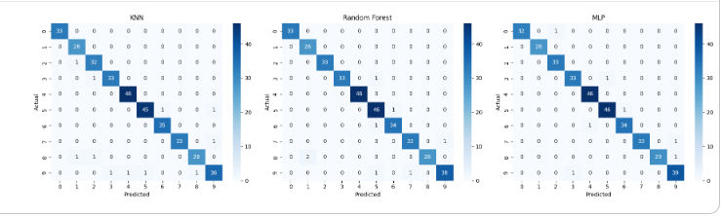
- Accuracy Score
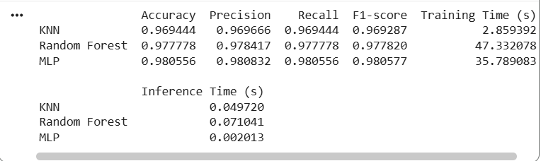
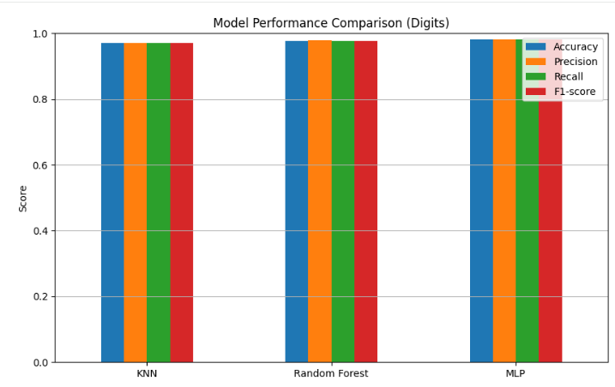

Observation and Result Analysis:
- Nature of the dataset
- During Training Process
- After the training Process
- Observation over the Learning Curve

Post Lab Exercise:
- Is KNN useful in regression-based problems?
Yes, KNN can be used for regression problems. Instead of majority voting, KNN uses the average of the nearest neighbors.
- Why is KNN a non-parametric algorithm?
KNN is called a non-parametric algorithm because it does not assume any mathematical model, does not learn parameters, and does not assume data distribution; it simply stores data and compares distances. It is model-free and data-driven.
- What are the assumptions of the KNN approach?
The assumptions of the KNN approach are:
- Similar points are close to each other: nearby points have similar labels;
- Data is properly scaled: distance calculations require normalized data;
- Relevant features exist: irrelevant features affect distance;
- Local smoothness: points near each other behave similarly.
- How can the KNN approach predict the unseen dataset?
The KNN approach predicts unseen datasets by using the entire training dataset to make predictions. When a new instance is encountered, KNN searches through the training dataset for the K most similar instances and uses the most common class label or average output variable from those instances to make a prediction.
- Why is KNN called a Lazy Learner?
KNN is called a lazy learner because it does not learn during training; it stores all data, and the learning process happens only during prediction. During the training phase there is no computation, and in prediction phase, there is a heavy computation. So, it delays learning until query time.
- Why should we not use KNN for a large dataset?
KNN is not suitable for large datasets because:
- High computation cost: distance calculation for every data point;
- High memory usage: it stores entire dataset;
- Slow prediction: it takes a time complexity of O(N) for each prediction;
- Curse dimensionality: in high dimensions, distances become meaningless;
- Poor scalability: not efficient for big data.

